# Climate indices

## Purpose

This module offers a set of functions to calculate climate indices for time series data. These functions are available:

* Determine historical 95th percentile
* Rx1day (Annual or monthly maximum 1-day precipitation)
* Rx5day (Annual or monthly maximum 5-day precipitation)
* Rnn (implied also R10 and R20; Annual days count with precipitation higher than user specified threshold)
* CDD (Maximum number of consecutive dry days)
* CWD (Maximum number of consecutive wet days)
* R95p (Annual total precipitation for very wet days, ie days with more than 95th percentile of historical precipitation, in the period 1961-1990)
* PRCPTOT (Annual total wet day precipitation)

The indices are a subset of the core indices of the ETCCDI/CRD Climate Change Indices

## Installation

Install the .sav files in the save_add folder (see also [ENVI .sav files: Installation and configuration](http://www.itc.nl/personal/nieuwenh/installations.html).

nrsmenu.pro Define NRS menu item in ENVI

nrs_Utils.sav Library with utility routines

nrs_precipitation_tools.sav The actual software

## Usage (gui)

|  |  |
| --- | --- |
| nrs_climind_perc_gui | Start the user interface to determine the 95th percentile historical precipitation. |
| nrs_climind_rx5day_gui | Start the user interface for the Rx1day and Rx5day indices. They are always calculated both. |
| nrs_climind_rnn_gui | Start the user interface of the drought index calculation. |
| nrs_climind_cdd_gui | Start the user interface for the CDD / CWD indices. |
| nrs_climind_r95p_gui | Start the user interface for the R95P index. |
| nrs_climind_ptot_gui | Start the user interface for the PRCPTOT index. |

Alternatively the commands can be started from the ENVI menu: ‘NRS | Climate indices:

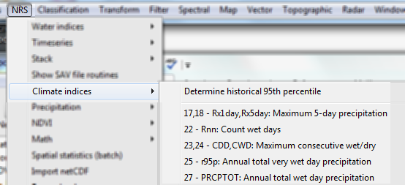

### Determine historical 95th percentile

Menu option is ‘NRS | Climate indices | Determine historical 95th percentile, the command line is ‘nrs_climind_perc_gui’. This module will calculate the 95th percentile of the precipitation on wet days (≥ 1 mm) in the period 1961-1990. The software supports two approaches to calculating this:

1. Straightforward percentile calculation
2. Using out-of-base estimation to avoid inhomogeneity (Zhang, Hegerl et al. 2005)

The software assumes the input time series is from 1961-1990 (10957 days).

The output is a new time series with annual percentile data.

The user interface is shown below:

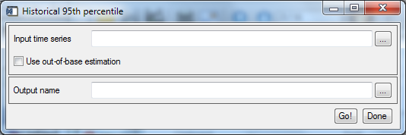

Explanation of all the fields:

|  |  |
| --- | --- |
| Input time series | Select an input precipitation time series |
| Use out-of-base estimation | If checked will calculate the percentiles with the procedure as outlined in (Zhang, Hegerl et al. 2005); if not checked straightforward percentile calculation is applied. |
| Output name | The filename for the output time series. |

### Rx1day / RX5day: Annual or monthly maximum 1-day/5-day precipitation

Menu option is ‘NRS | Climate indices | 17,18 - Rx1day,Rx5day: Maximum 1-day/5-day precipitation, the command line is ‘nrs_climind_rx5day_gui’. This module can calculate the maximum 1-day precipitation or the maximum 5-day precipitation and do this either monthly or yearly.

Rx1day Maximum 1-day precipitation: Let RRij be the daily precipitation amount on day *i* in period *j*. The maximum 1-day value for period *j* is: Rx1dayj = max(RRij)

Rx5day Maximum consecutive 5-day precipitation: Let RRkj be the precipitation amount for the 5-day interval ending *k*, period *j*. Then maximum 5-day value for period *j* is: Rx5dayj = max (RRkj)

The output is a new time series with annual or monthly precipitation data.

The user interface is shown below:

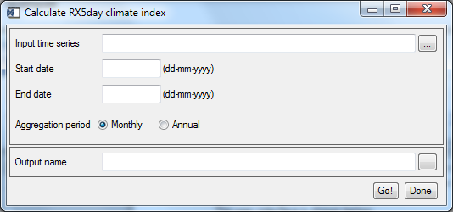

Explanation of all the fields:

|  |  |
| --- | --- |
| Input time series | Select an input precipitation time series |
| Start date | Specifies the date associated with the first band. |
| End date | Specifies the date associated with the last band. |
| Aggregation period | Select output monthly or yearly. |
| Output name | The filename for the output time series. |

### Rnn: Annual days count with precipitation higher than specified threshold

Menu option is ‘NRS | Climate indices | 22 - Rnn: Count wet days, the command line is ‘nrs_climind_rnn_gui’. This module will count all days with a precipitation higher than a user specified limit. Note that this also implies the R10 and R20 indices that use 10 mm and 20 mm respectively.

Rnn Annual count of days when PRCP≥ nn mm, where nn is a user defined threshold: Let RRij be the daily precipitation amount on day i in period j. Count the number of days where RRij ≥ nn mm.

The output is a new time series with annual day count data.

The user interface is shown below:

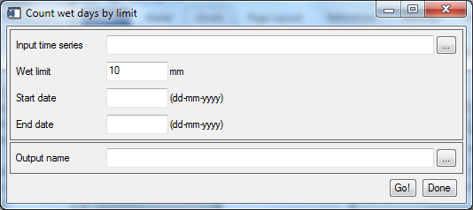

Explanation of all the fields:

|  |  |
| --- | --- |
| Input time series | Select an input precipitation time series |
| Wet limit | Specify the limit for counting days |
| Start date | Specifies the date associated with the first band. |
| End date | Specifies the date associated with the last band. |
| Output name | The filename for the output time series. |

### CDD / CWD: Maximum number of consecutive dry / wet days

Menu option is ‘NRS | Climate indices | 23,24 - Maximum consecutive dry/wet, the command line is ‘nrs_climind_cdd_gui’. This module will both calculate the dry and wet spells.

CDD Maximum length of dry spell, maximum number of consecutive days with RR < 1mm: Let RRij be the daily precipitation amount on day *i* in period *j*. Count the largest number of consecutive days where RRij < 1mm.

CWD Maximum length of wet spell, maximum number of consecutive days with RR ≥ 1mm: Let RRij be the daily precipitation amount on day *i* in period *j*. Count the largest number of consecutive days where RRij ≥ 1mm.

The software extends the definition, by allowing the limit to be user specified. The default limit still is 1 mm.

The output contains two bands, one with CDD index and one with the CWD index. The current version calculates the indices for the entire period only.

The user interface is shown below:

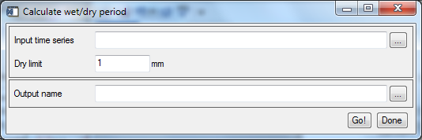

Explanation of all the fields:

|  |  |
| --- | --- |
| Input time series | Select an input precipitation time series |
| Dry limit | The optional user defined limit (default 1 mm). |
| Output name | The filename for the output image. |

### r95ptot: Annual total very wet day precipitation

Menu option is ‘NRS | Climate indices | 25 - r95p: Annual total very wet day precipitation, the command line is ‘nrs_climind_r95p_gui’. This module will calculate the annually accumulated precipitation on very wet days, where the precipitation is higher than the 95th percentile of 30 years of historical data (usually 1960 to and including 1990).

R95pTOT Annual total PRCP when RR > 95p. Let RRwj be the daily precipitation amount on a wet day w (RR ≥ 1.0mm) in period *i* and let RRwn95 be the 95th percentile of precipitation on wet days in the 1961-1990 period. If W represents the number of wet days in the period, then: ${R95Ptot}_{j}=\sum_{w=1}^{W}{{RR}_{wj}}$, where RRwj ≥ RRwn95.

The 95th percentile data can be calculated separately by *Determine historical 95th percentile*

The software supports only the annual period (*j).*

The user interface is shown below:

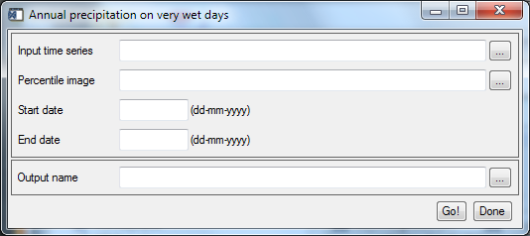

Explanation of all the fields:

|  |  |
| --- | --- |
| Input time series | Select an input precipitation time series |
| Percentile image | Select the historical 95th percentile precipitation image |
| Start date | Specifies the date associated with the first band. |
| End date | Specifies the date associated with the last band. |
| Output name | The filename for the output time series. |

### PRCPTOT: Annual total wet day precipitation

Menu option is ‘NRS | Climate indices | 27 - PRCPTOT: Annual total wet day precipitation, the command line is ‘nrs_climind_ptot_gui’. This module will calculate the annually accumulated precipitation on wet days (precipitation ≥ 1 mm).

PRCPTOT Annual total precipitation in wet days: Let RRij be the daily precipitation amount on day *i* in period *j*. If I represents the number of days in *j*, then: ${PRCPTOT}_{j}=\sum_{i=1}^{I}{{RR}_{ij}}$, where RRij ≥ 1 mm.

The software supports only the annual period (*j).*

The user interface is shown below:

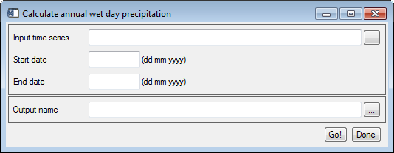

Explanation of all the fields:

|  |  |
| --- | --- |
| Input time series | Select an input precipitation time series |
| Start date | Specifies the date associated with the first band. |
| End date | Specifies the date associated with the last band. |
| Output name | The filename for the output time series. |

### References

ETCCDI/CRD Climate Change Indices: <http://etccdi.pacificclimate.org/list_27_indices.shtml> The main list with the definitions of the 27 core climate indices

Zhang, X., G. Hegerl, et al. (2005). "Avoiding inhomogeneity in percentile-based indices of temperature extremes." Journal of Climate **18**(11): 1641-1651.